1. Java Sort :
#CODE:
import java.util.*;

class Student {
private int id;
private String fname;
private double cgpa;

public Student(int id, String fname, double cgpa) {
this.id = id;
this.fname = fname;
this.cgpa = cgpa;
}

public int getID() {
return id;
}

public String getFname() {
return fname;
}

public double getCgpa() {
return cgpa;
}
}

class Checker implements Comparator<Student> {

@Override
public int compare(Student a, Student b) {

// 1. CGPA - decreasing order
if (a.getCgpa() != b.getCgpa()) {
return Double.compare(b.getCgpa(), a.getCgpa());
}

// 2. First name - alphabetical order
if (!a.getFname().equals(b.getFname())) {
return a.getFname().compareTo(b.getFname());
}

// 3. ID - increasing order
return Integer.compare(a.getID(), b.getID());
}
}

public class Solution {

public static void main(String[] args) {

Scanner sc = new Scanner(System.in);

int n = sc.nextInt();

List<Student> students = new ArrayList<>();

for (int i = 0; i < n; i++) {

int id = sc.nextInt();
String fname = sc.next();
double cgpa = sc.nextDouble();

students.add(new Student(id, fname, cgpa));
}

Collections.sort(students, new Checker());

for (Student student : students) {
System.out.println(student.getFname());
}

sc.close();
}
}

OUTPUT:
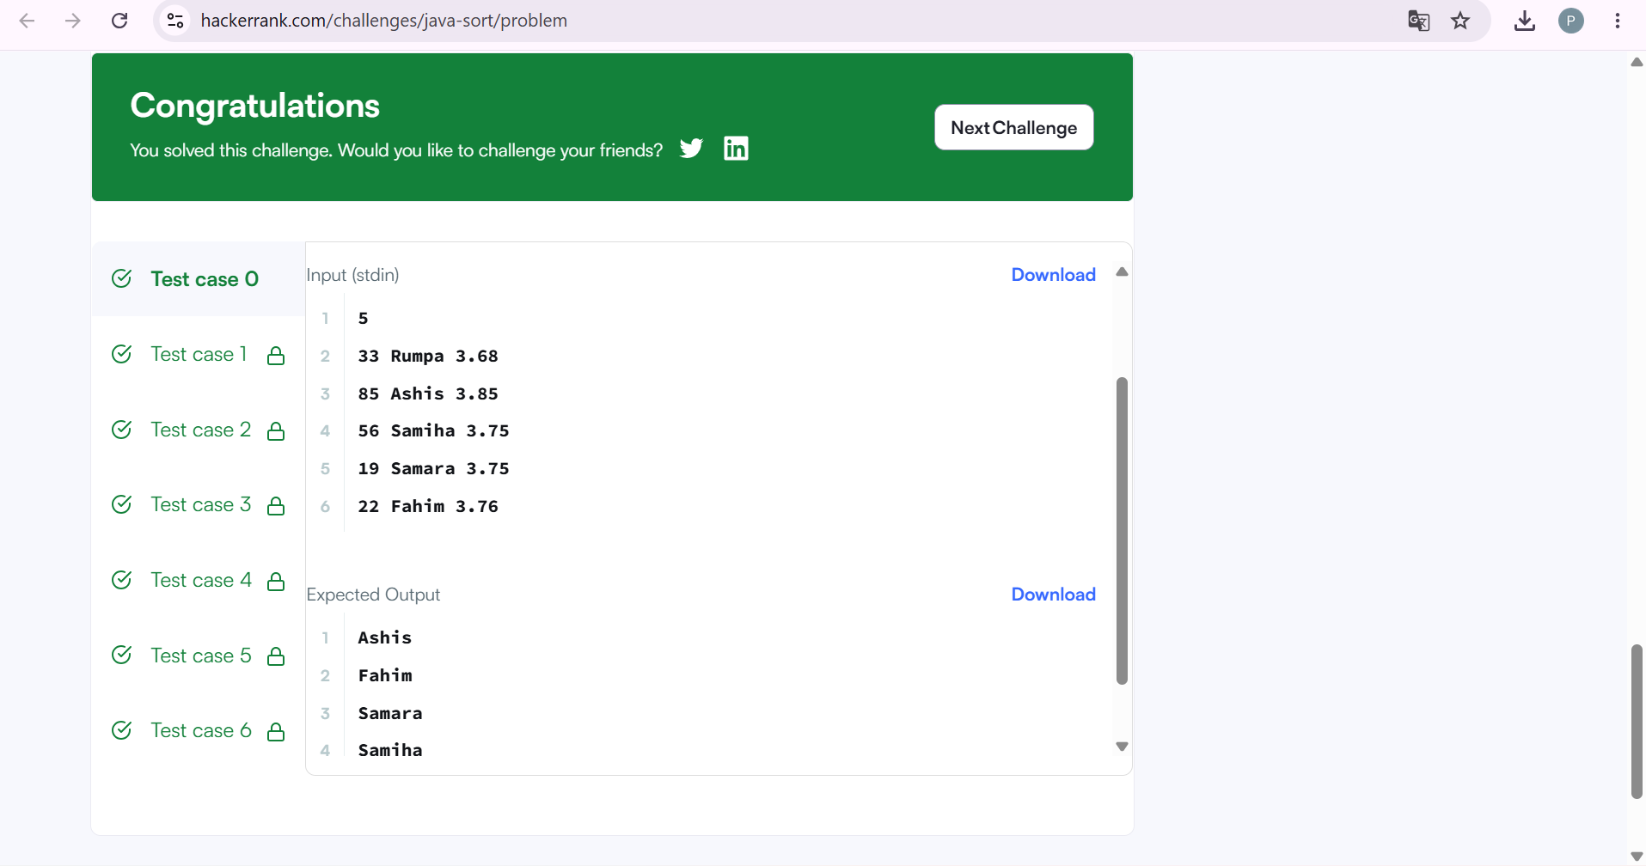

2. Sort Array By Parity :
#CODE:
class Solution {
public int[] sortArrayByParity(int[] nums) {
int[] result = new int[nums.length];
int index = 0;

// Put even numbers first
for (int num : nums) {
if (num % 2 == 0) {
result[index] = num;
index++;
}
}

// Put odd numbers next
for (int num : nums) {
if (num % 2 != 0) {
result[index] = num;
index++;
}
}

return result;
}
}

OUTPUT:
